

**Tribhuvan University**

**Institute of Engineering**

**Purwanchal Campus, Dharan**

**C-Programming Lab Report**

Prepared by:- Nigam Yadav

**LAB SHEET NO.3[To be familiar with the selective structure (branching)]**

Flowchart:

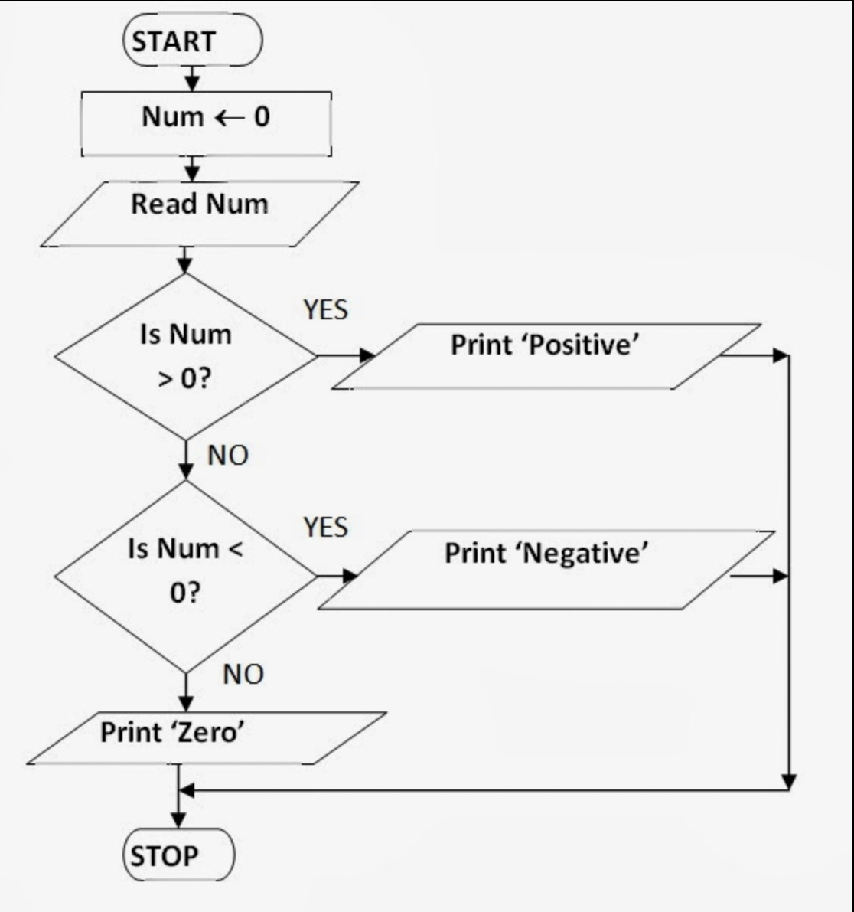

**Code:-**

1.WAP to check whether a number is negative, positive or zero.

#include<stdio.h>

#include<stdlib.h>

int main()

{

int n;

printf("Enter the value of n:");

scanf("%d",&n);

if(n==0)

printf("the number is zero");

else if(n>=1)

printf("the number is positive");

else

printf("the number is negative");

return 0;

}

Output

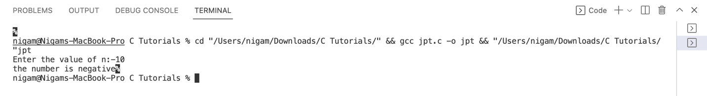

2.WAP to find maximum number between three numbers entered by the user.

Flowchart:

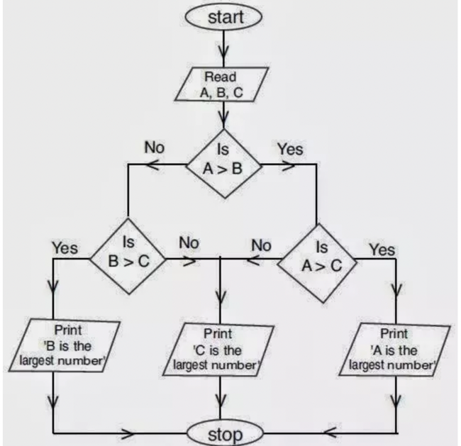

**Code:-**

#include<stdio.h>

int main()

{

int a, b ,c;

printf("Enter the values of three numbers:");

scanf("%d%d%d",&a,&b,&c);

if(a>b)

{

if(a>c)

printf("the maximum value is %d",a);

}

else if(b>c)

{

if(b>a)

printf("the maximum value is %d",b);

}

else

printf("the maximum value is %d",c);

return 0;

}

Output

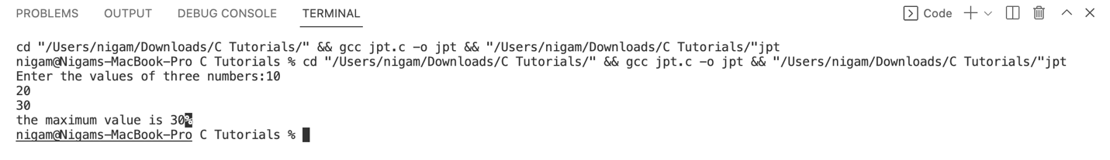

3.WAP to input a character from the user and check whether the character is vowel or consonant.

Flowchart:

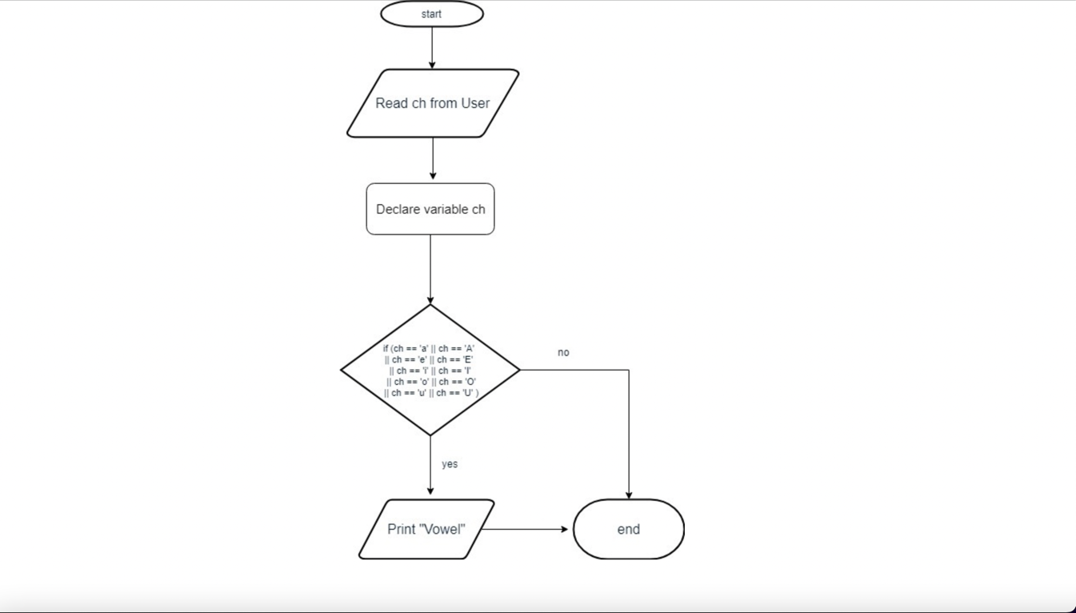

**Code:-**

#include<stdio.h>

int main()

{

char ch;

printf("Enter a character:");

scanf("%c",&ch);

if (ch=='a'||ch=='e'||ch=='i'||ch=='o'||ch=='u')

{

printf("%c is vowel",ch);

}

else

printf("%c is consonant",ch);

return 0;

}

Output

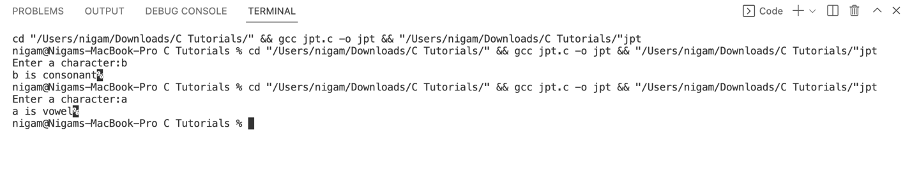

4.WAP to input a character from the user and check whether the character is Alphabet or not. If the character is Alphabet then show whether it is uppercase or lowercase.

Flowchart:

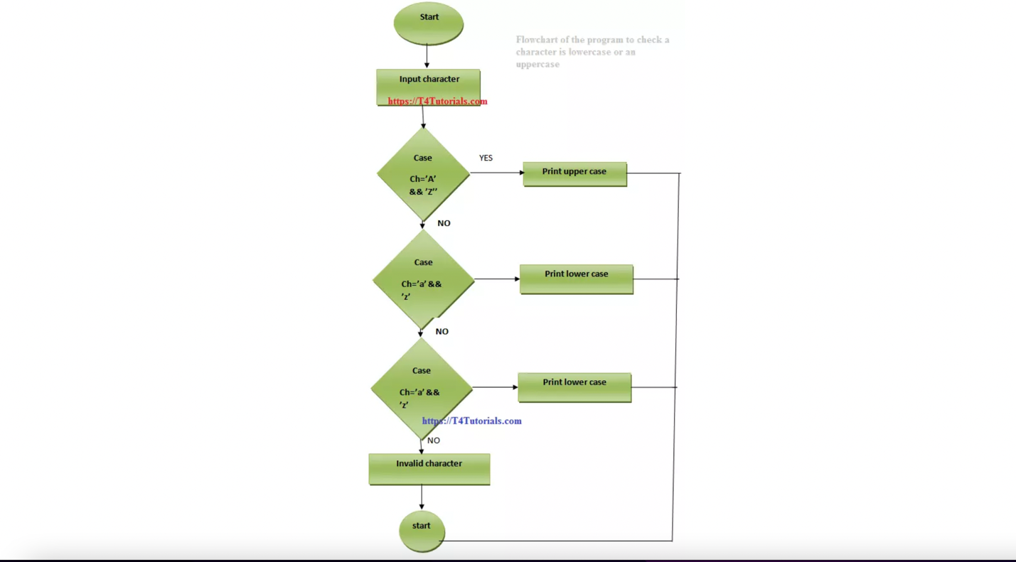

**Code:-**

#include<stdio.h>

int main()

{

char ch;

printf("Enter a character:");

scanf("%c",&ch);

if((ch>='a'&& ch<='z')||(ch>='A'&& ch<='Z'))

{

printf("%c is a alphabet\n",ch);

if(ch>='a'&& ch<='z')

{

printf("%c is a lowercase alphabet.\n",ch);

}

else

{

printf("%c is a uppercase alphabet.\n",ch);

}

}

else

{

printf("%c is not a character",ch);

}

}

Output

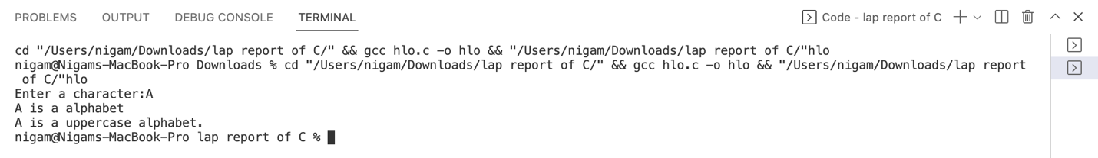

5.WAP to check whether the year entered by the user is leap year or not.

Flowchart:

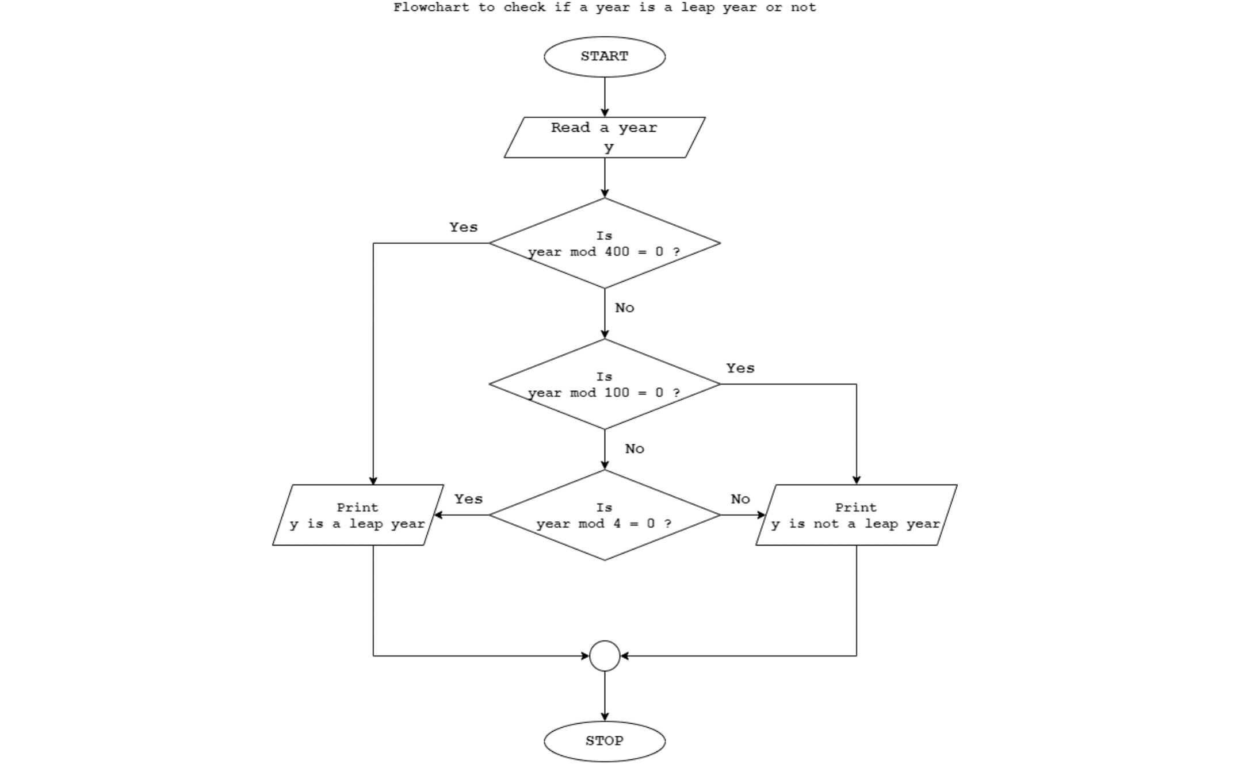

**Code:-**

#include<stdio.h>

int main()

{

int year;

printf("Enter a year and I will check whether it is a leap year or not:");

scanf("%d",&year);

if (year%4==0 ||(year%100!=0 && year%400==0))

{

printf("%d is a leap year",year);

}

else

printf("%d is not a leap year",year);

return 0;

}

Output

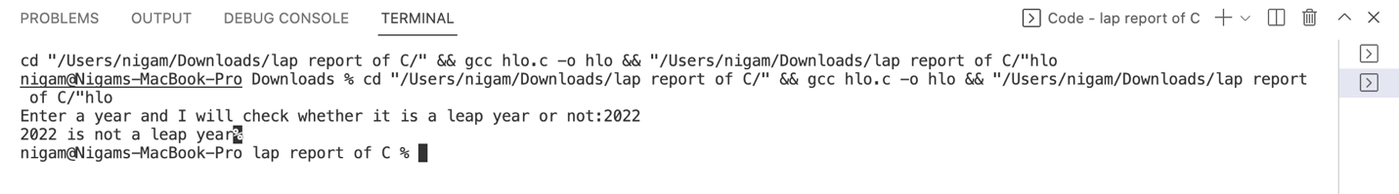

6.WAP to check whether the number entered by the user is divisible by the user is divisible by 5 and 11 or not.

Flowchart:

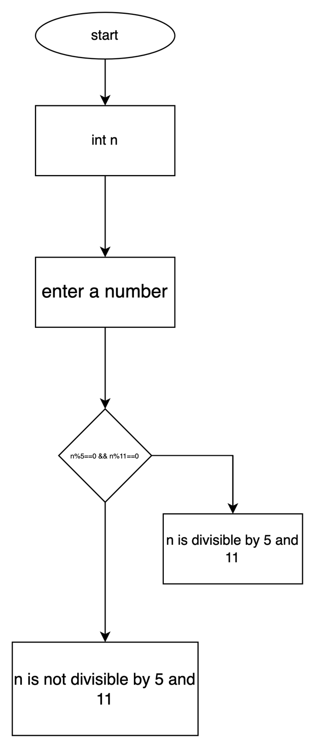

**Code:-**

#include<stdio.h>

int main()

{

int n;

printf("Enter a number:");

scanf("%d",&n);

if(n%5==0&&n%11==0)

printf("%d is divisible by 5 and 11",n);

else

printf("%d is not divisible by 5 and 11",n);

return 0;

}

Output

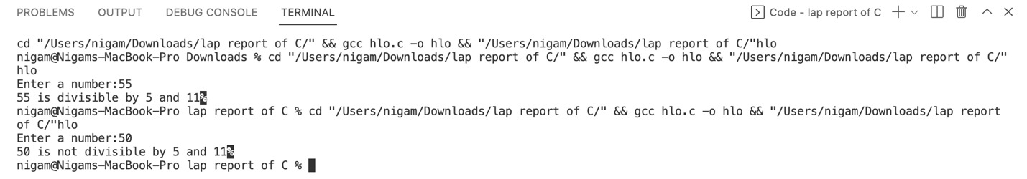

7.WAP to find the all the roots of a quadratic equation.

Flowchart:

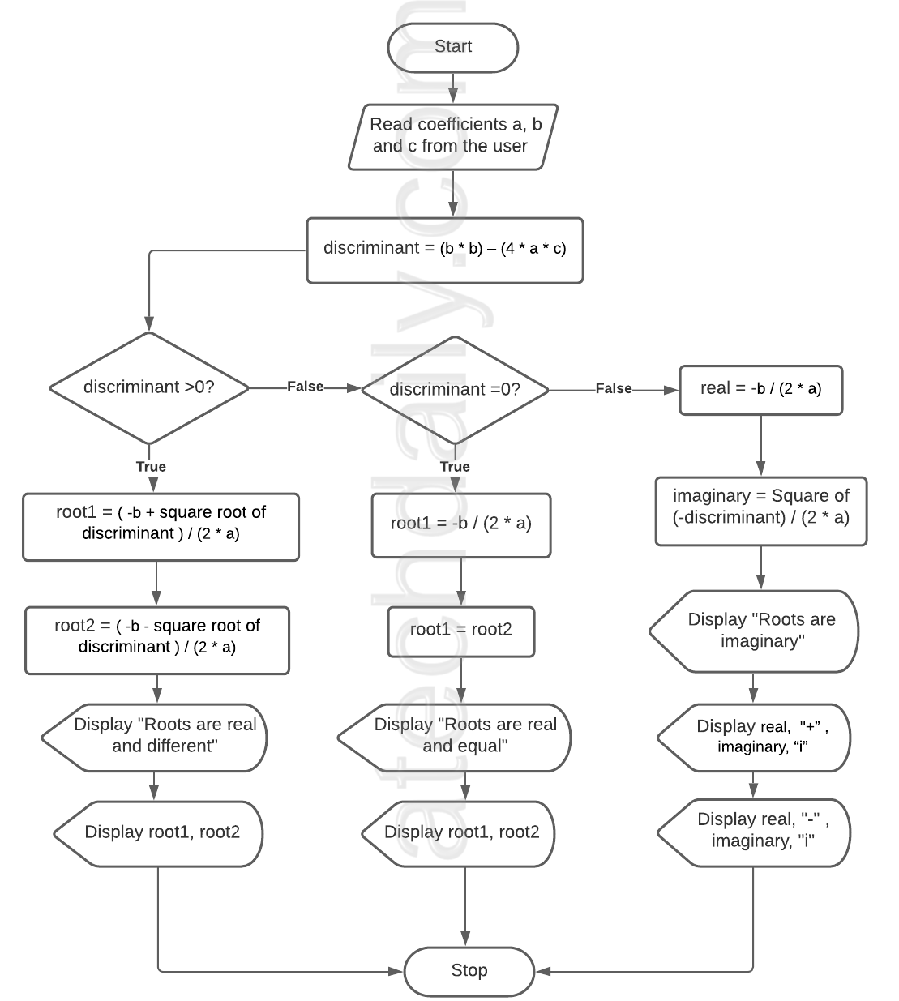

**Code**:

#include<stdio.h>

#include<math.h>

int main()

{

double a,b,c,discriminant,root1,root2,real,img;

printf("Enter the values of a,b and c");

scanf("%lf%lf%lf",&a,&b,&c);

discriminant = b*b - 4.0 * a * c;

if(discriminant == 0)

{

root1=root2= -b/(2.0*a);

printf("Roots are real and equal\n");

printf("root1=root2 =%lf",root1);

}

else if(discriminant>0)

{

root1= (-b+ sqrt(discriminant))/(2.0*a);

root2 = (-b- sqrt(discriminant))/(2.0*a);

printf("Roots are real and unequal\n");

printf("root1 = %lf+%lfi and root2 = %lf-%lfi",real,img,real,img);

}

return 0;

}

Output

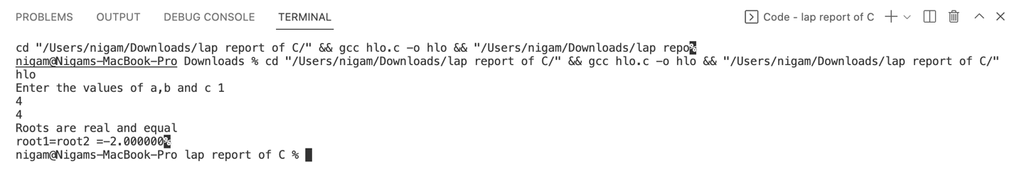

8.WAp to input two numbers and operator among [+, -, *, /]. If user enters + then the program should perform the addition of the number and display the sum. If users enters – then program should perform subtraction of numbers and display the difference and so on for * and /.

Flowchart:

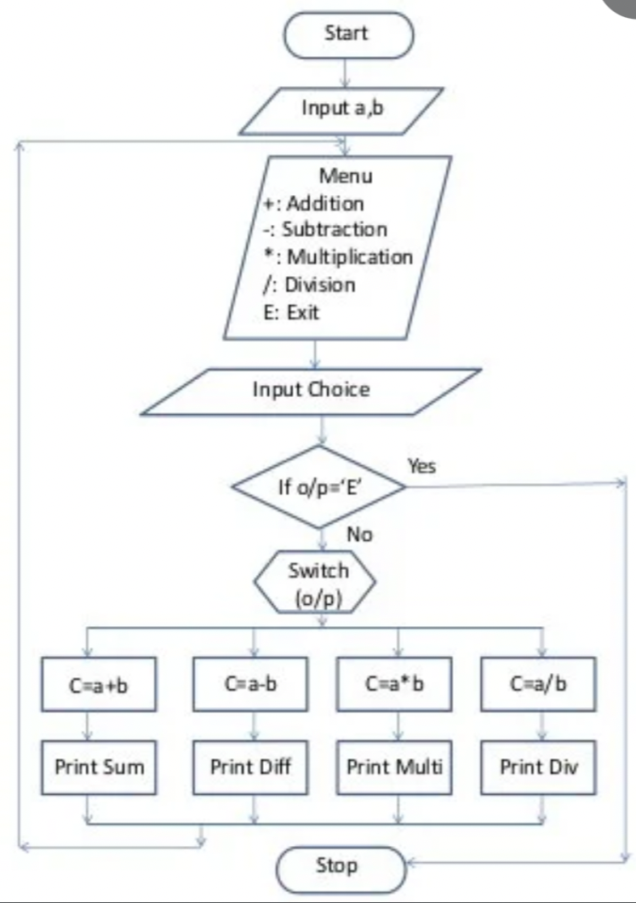

**Code:-**

#include<stdio.h>

int main()

{

float a,b,ans;

char op;

printf("Enter the values of a and b ");

scanf("%f%f",&a,&b);

printf("Enter + for addition\n Enter - for subtraction\n Enter * for multiplication\n Enter / for division\n");

scanf(" %c",&op);

switch(op)

{

case'+':ans =a+b;

printf("The sum of %f and %f is %f",a,b,ans);

break;

case'-':ans =a-b;

printf("The subtraction of %f and %f is %f",a,b,ans);

break;

case'*':ans =a*b;

printf("The product of %f and %f is %f",a,b,ans);

break;

case'/':ans =a/b;

printf("The quotient of %f and %f is %f",a,b,ans);

break;

default: printf("Invalid input");

}

return 0;

}

Output

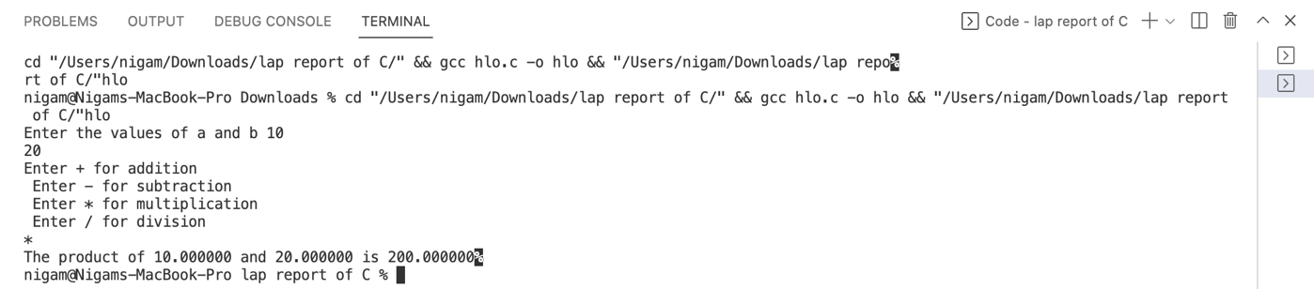

9.WAP in C to input marks of five subjects C-programming, Physics, Math, Applied Mechanics and Basic electrical. Display the student passed or failed. Take F.M.=100 and P.M.=40 For passed students calculate percentage and grade according to following:

Percentage >=90% : A

Percentage >=80% : B

Percentage >=70% : C

Percentage >=60% : D

Percentage >=40% : E

Flowchart:

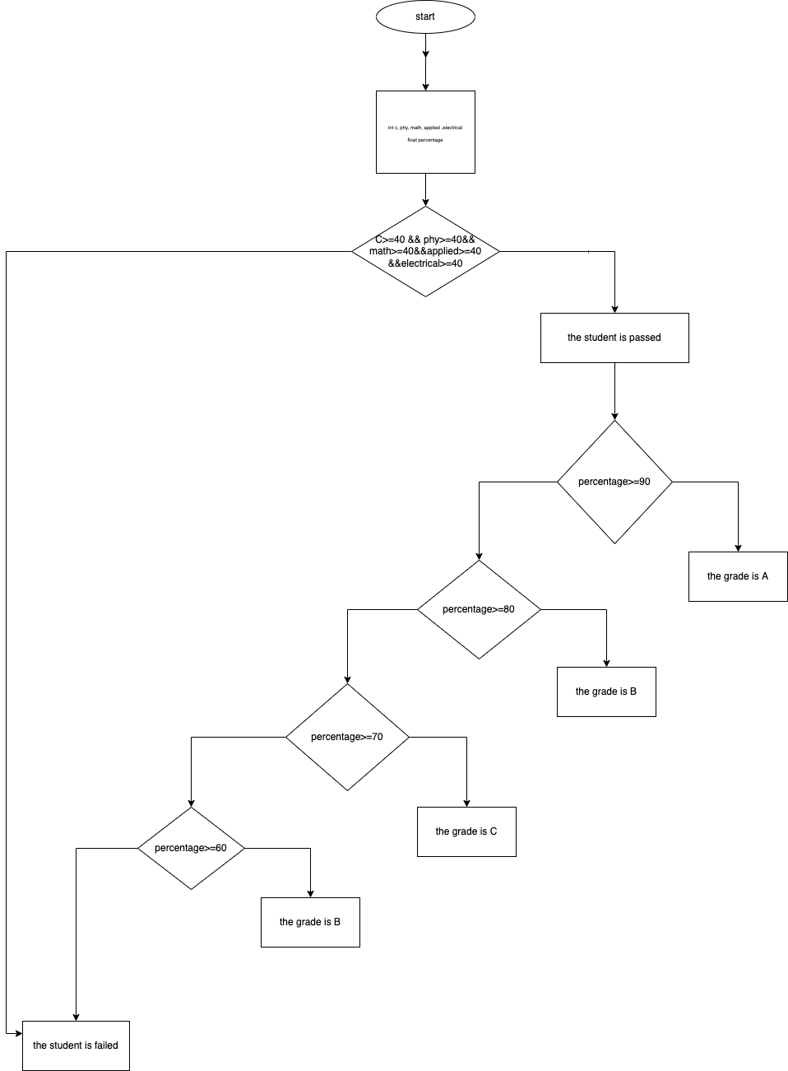**Code:-**

#include<stdio.h>

int main()

{

int C, phy,math,applied,elecrical;

float percentage;

printf("Enter the marks obtain in C-programmming,Physics,Maths,Applied mechanics and basic electrical: ");

scanf("%d%d%d%d%d",&C,&phy,&math,&applied,&elecrical);

if(C>=40 && phy>=40 && math>=40 && applied>=40 && elecrical>=40)

{

printf("the student is passed\n");

percentage = (C+phy+math+applied+elecrical)/5;

printf("the percentage is %f\n",percentage);

if(percentage>=90)

printf("the grade is A\n");

else if(percentage>=80)

printf("the grade is B\n");

else if(percentage>=70)

printf("the grade is C\n");

else if(percentage>=60)

printf("the grade is D\n");

else if(percentage>=40)

printf("the grade is E\n");

}

else

printf("the student is failed");

return 0;

}

Output

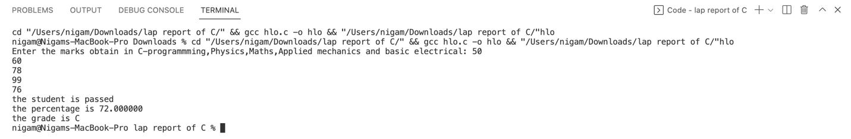

10.WAP to input a number from user. If user enters a number less than or equal to zero then program should just display the number. If the user enters 1 the program should display output as neither prime or composite, if the user enters 2 the program should display output as smallest and only even prime number. If user enters any number greater than 2 the program should check whether the number is prime or not, also if the number is not prime the program should display whether it is even or odd.

Flowchart:

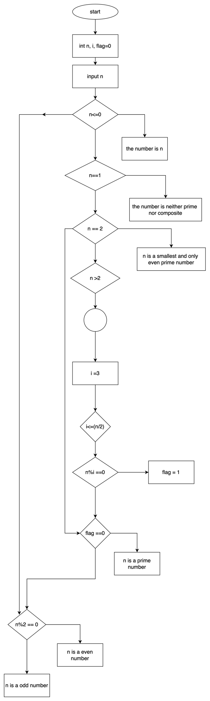

**Code:-**

#include<stdio.h>

int main()

{

int n,i,flag=0;

printf("Enter a number:");

scanf("%d",&n);

if(n<=0)

printf("the number is %d",n);

else if(n==1)

printf("the number is neither prime nor composite");

else if(n==2)

printf("%d is a smallest and only even prime number",n);

else if(n>2)

{

for(i=3;i<=(n/2);i++)

{

if(n%i==0)

{

flag=1;

break;

}

}

}

if(flag==0)

printf("%d is a prime number",n);

else

{

if(n%2==0)

{

printf("%d is a even number",n);

}

else

printf("%d is a odd number",n);

}

return 0;

}

Output

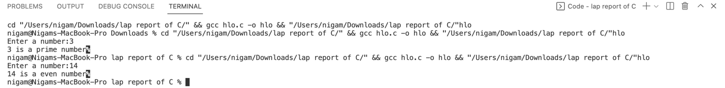

**Conclusion**:-

After completing this lab sheet, I got so many knowledge and learn how to recognize error and eliminate them. In this report, all the question are logic based so it helps me to improve my logical concept and logic building technique. It taught to use control statement, loop and nested if else while solving different problems……